**Creating Game in Python Programming Language**

**Kevin Karanja Wachira**

**Naivasha,2023**

**Purpose:**

* To be able to control a program using time
* To be able to breakdown a complex large task into simpler simple task that are easy to understand
* To be able to program tasks that can be applied in different fields in world technology

**Theory:**

In creating code which can be used in real world entities one should know that they are always very complex.To solve them one need to first to understand the processes that make up the whole task.

Then one should start solving each task process one after the other and then assemble all process in the order of how he or she understand the task.

When you want to control your program using time especially if it’s a repeating process one first need to declare startingtime and also one should declare time limit.

where one import time module which get initial time immediately when the process start When a process is repetitive one need to make a process to be executed inside a indefinite loop which can only stops when timelimit is exceded.

**Task:**

Two navies A(Player 1) and B(Player 2) each with x and y war ships respectively, start shooting at each other in the sea. You are required to develop an OOP model for this game. Make it possible for 1 player to play against the computer.

**Solution:**

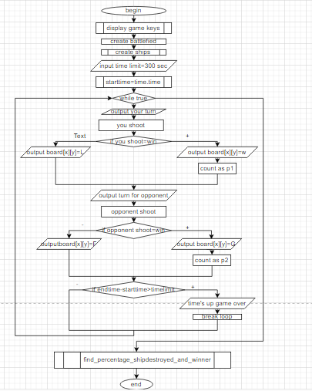

**Code:**

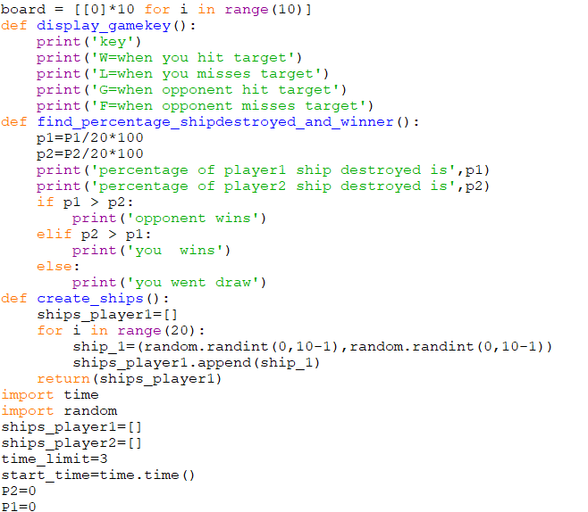

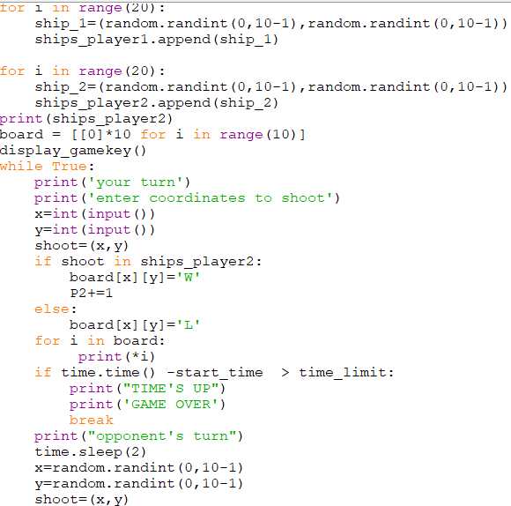

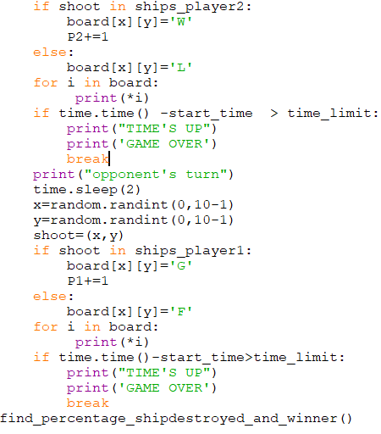



**Test Data:**

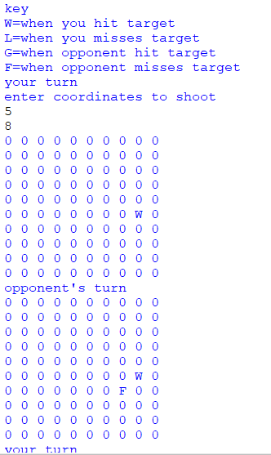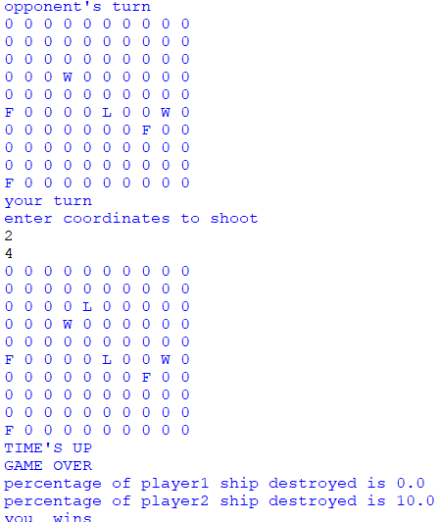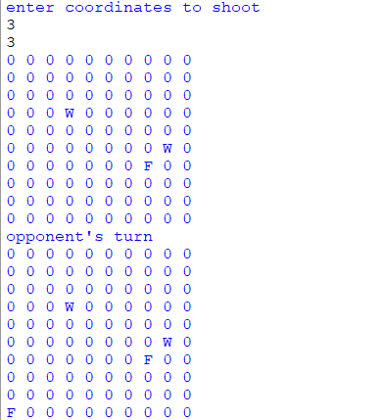

**Conclusion:**

The best way to solve complex large tasks is using function to create subprograms and then assemble all sub programs to make the main program.